Name: Andrew Duong

Date: 10-30-2020

Team: Team Hydro

Individual work performed on planned tasks this period:

|  |  |  |  |
| --- | --- | --- | --- |
| Task Description | Planned Work (work units) | Actual Work (work units) | % Complete |
| Demo Field Entry in an Android App | 1 | 1 | 100% |
| Use Field Entry to add Strings of Temperature and SG to ArrayList of Strings | 1 | 0.33 | 33% |

Individual work planned for next period:

|  |  |  |
| --- | --- | --- |
| Task Description | Date Due | Planned Work (work units) |
| Use Field Entry to add Strings of Temperature and SG to ArrayList of Strings | 11/16/20 | 0.67 |
| Testing Bluetooth on Android | 11/9/20 | 0.5 |

Individual work performed on unplanned tasks this period:

|  |  |
| --- | --- |
| Task Description | Actual Work (work units) |
| Testing Bluetooth on Android | 0.25 |

List any problems encountered or unresolved issues:

The issue I encountered is that the data refused to save and regardless of what I input in any of the fields. Tapping the Submit button will crash the app entirely. Therefore, I need to put much more work on getting the manual data entry feature to work. Before I can even use it to store data for temperature and specific gravity manually.

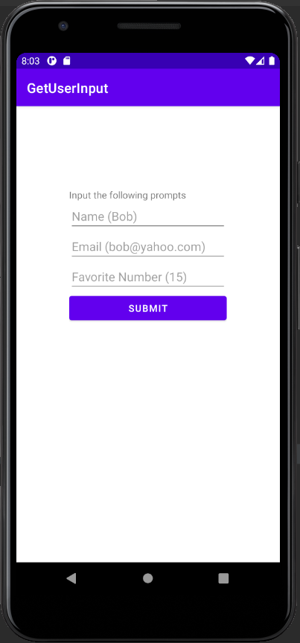

I’m also testing a separate app for Bluetooth Connect and Pairing on Android refuses to build in Android Studio on my PC for reasons relating to missing XML and PNG files I still couldn’t figure out.

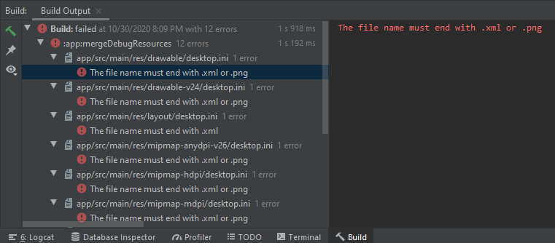

List any key lessons learned: